University of Mianwali.



Department of SE
Software Requirement Specification
Assignment
Name: | Hassan Raza
Roll no: | BSE-F23-M49
Date Performed | 07/08/2025
Instructors | Sir Asif Raza

Online Learning Management System:

Use Case Diagram:

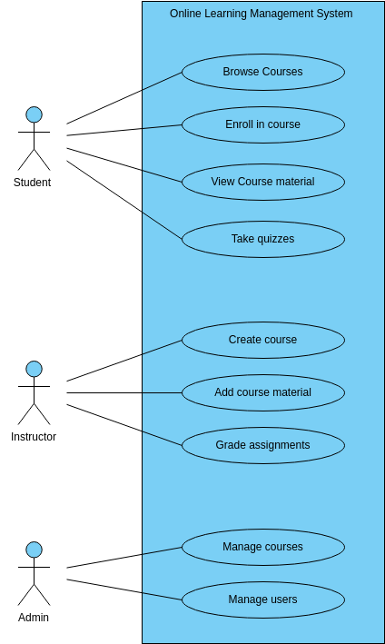

USE CASE DESCRIPTIONS

Student Use Cases:

UC-01: View Courses
Description: Student can browse available courses and view details.
Preconditions: Platform must be accessible.
Postconditions: Course list and details are shown.
Success Scenario:
- Open website
- Navigate to 'All Courses'
- Apply filters (e.g., category, price)
- View course syllabus, instructor info
Extensions:
- No courses found
- Server error while loading
Frequency of Use: Very High
Status: Completed
Owner: Frontend Developer
Priority: High

UC-02: Enroll in Course
Description: Student enrolls by purchasing a course.
Preconditions: Student must be logged in.
Postconditions: Course added to student's profile.
Success Scenario:
- Select a course
- Click 'Enroll Now'
- Make payment
- Get enrollment confirmation
Extensions:
- Payment failure
- Course already enrolled
Frequency of Use: Frequent
Status: In Development
Owner: Full Stack Developer
Priority: Critical

UC-03: View Progress
Description: Student checks learning progress (videos completed, quizzes passed).
Preconditions: Student must be enrolled.
Postconditions: Progress bar and status updated.
Success Scenario:
- Go to ‘My Courses’
- Open any course
- See completed modules, pending assignments
Extensions:
- Progress not saved
- Stats not updated
Frequency of Use: High
Status: Ongoing
Owner: Backend Developer
Priority: Medium

Instructor Use Cases:

UC-04: Create Course
Description: Instructor creates a new course.
Preconditions: Instructor must be logged in and verified.
Postconditions: Course draft saved in system.
Success Scenario:
- Go to dashboard
- Click 'Create Course'
- Add title, description, syllabus
- Upload intro video
Extensions:
- Missing required fields
- Upload failure
Frequency of Use: Occasionally
Status: In Progress
Owner: Instructor Dashboard Developer
Priority: High

UC-05: Update Course
Description: Instructor edits course content.
Preconditions: Course must already exist.
Postconditions: Content updated in real-time.
Success Scenario:
- Open course from dashboard
- Edit video, text, or quiz
- Save and publish changes
Extensions:
- Version conflict
- Save failed
Frequency of Use: Moderate
Status: Ongoing
Owner: Instructor Module Developer
Priority: Medium

UC-06: Grade Assignments
Description: Instructor reviews and grades student submissions.
Preconditions: Students must have submitted assignments.
Postconditions: Grades are assigned.
Success Scenario:
- Go to assignment section
- View student answers
- Enter marks and comments
- Submit grades
Extensions:
- File not opening
- Mistaken submission
Frequency of Use: Moderate
Status: Pending
Owner: Backend Developer
Priority: Medium

Admin Use Cases:

UC-07: Manage Accounts
Description: Admin manages user accounts (activate, suspend).
Preconditions: Admin must be logged in.
Postconditions: User access is updated.
Success Scenario:
- Open admin panel
- Search for user
- Change status or details
Extensions:
- Unauthorized access
- User not found
Frequency of Use: Weekly
Status: Ongoing
Owner: Admin Panel Developer
Priority: High

UC-08: Manage Courses
Description: Admin approves, edits, or deletes courses.
Preconditions: Course must be submitted by instructor.
Postconditions: Course status updated.
Success Scenario:
- View new course submissions
- Approve or reject
- Edit content if needed
Extensions:
- Duplicate content
- Policy violation
Frequency of Use: Weekly
Status: Planned
Owner: Admin System Developer
Priority: Medium

UC-09: View Reports
Description: Admin sees system activity, revenue, enrollments.
Preconditions: Admin access required.
Postconditions: Reports generated or exported.
Success Scenario:
- Go to analytics section
- View graphs of sales, active users
- Export data
Extensions:
- Report failed to load
- Incorrect data displayed
Frequency of Use: Weekly
Status: Ongoing
Owner: System Admin
Priority: Medium

